**ENERGY CONSUMPTION MEASUREMENTS**

**Definitions**

Measurement is the process by which numbers or symbols are assigned to attributes Of entities in the real world in such a way as to describe them according to clearly.Defined rules (Fenton et al. 1997).

Example

We need to compare the reliability of software systems. Using the GQM approach the authors provide several software measures(metrics) through questions. The following are the questions and metrics that they selected.

**Meaning and Advantages:**

Lack of measurable targets (Gilb’s principle) If you do not know what to measure, you cannot improve anything.

• Identification failure If you identify your goals or metrics wrongly, your results do not help you to Improve; moreover, they can even make your processes worse.

• Lack of quality assurance If you cannot measure what you are doing, you cannot ensure quality becauseYou are not capable of controlling the process.

**Representation Condition:**

Representation Condition A measurement mapping must map entities into numbers and empirical relations into numerical relations that preserve them and viceVersa (Fenton et al. 1997).

The measure is valid if it satisfies the Representation Condition.

**Measurement Characteristics:**

Measurement should meet the following characteristics:

• Sensitivity Instrument’s ability to accurately measure variability in responses.

Example

A dichotomous response category, such as “agree or disagree,” does not allowThe recording of subtle attitude changes.

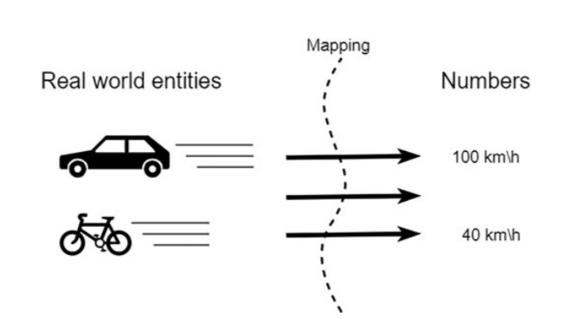

**KINDS AND MERITS:**

Objective and subjective

A metric is objective if it can be taken by an automated device. The metric is

Subjective otherwise.

Examples

• LOC is an objective metric, and Function Points are subjective.

• Measuring how well someone can complete a set number of assignments in a Controlled environment is objective.

• Measuring how difficult it was to write the code is subjective.Direct and indirect A metric is direct if it can be directly detected and indirect if it is the result of Mathematical elaboration on other metrics.

Measurement Scales

The kind of data received defines the relevant measurement scale. Also, the Measurement scale defines the relevant statistical method for analyzing actual data And making conclusions from that data. Each type of measurement scale has a Specific use.A measurement scale is a class of mapping that links empirical and number Relations with specific properties.

Each measurement scale should satisfy one or more of the following characteristics:

• Identity—every number on the measurement scale has to be unique.

• Ordered relationship—values should have ordered relationship to one another (magnitude). For example, some values are less and some are more than others.

• Equal intervals—scale units are equal to each other. This characteristic means, for

Instance, that the difference between 10 and 11 should be equal to the difference Between 21 and 22.

• A minimum value of zero—the scale should have a true zero point. There should Be no values below this point. Measurement distinguishes different classes of how to assign symbols to realworld aspects: nominal, ordinal, interval, ratio, and absolute scales.

• Nominal We use a nominal scale if we create categories and assign real-world entities to These categories. Values attached to variables show a category but do not have an Original numerical value. For nominal, any 1:1 mapping is OK.

Example

Gender. This is a variable that is measured on a nominal scale. People may be Categorized as “female” or “male,” but neither value shows less or more “gender”Than the other.

• Ordinal If we can rank the categories of symbols so that we can say that something is Higher, larger, smaller, etc., we need an ordinal scale. It satisfies identity and Magnitude characteristics. Each value on this scale is unique. Also, ordinal scales Show the order of the data according to some criteria. For ordinal, the mapping Needs to be strictly increasing.

Equipment:

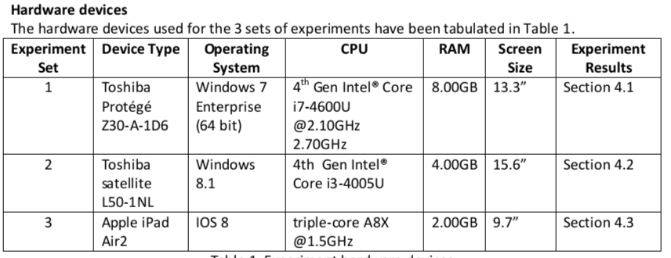Experimental Steps

1. Create a csv file for saving the real time power consumption data via Joulemeter (by clicking

On the browse button);

1. Click on the start saving button;
2. Click on the start button to run the application in Google Chrome 1.3.27 (i.e a youtube

Video3);

1. Click on the stop saving button to end the application;
2. Repeat the above steps for 9 times;
3. Repeat all the above steps for each of the following web browser: Internet Explorer 9;

Mozilla Firefox 27.0.1; and Safari 5.2.1.

Figure 1: Sample interface for the Joulemeter Measuring Tool

The constants of this experiment are:

1. The wifi network used is eudroam;
2. Constant environment (experiment is carried out within the same office throughout the

Entire experiment);

1. The time for all the experiments is from 1200 -1600 for Day 1 and Day 2.

The limitations of the experiments are:

1. The Joulemeter only monitors the energy consumption of the client machine;
2. Human inconsistency involved when clicking on the essential buttons (see % error due to in

Technical inconsistency which rendered several of the experiments as errors (Table 2).